PRACTICE SUMS
CASH BOOK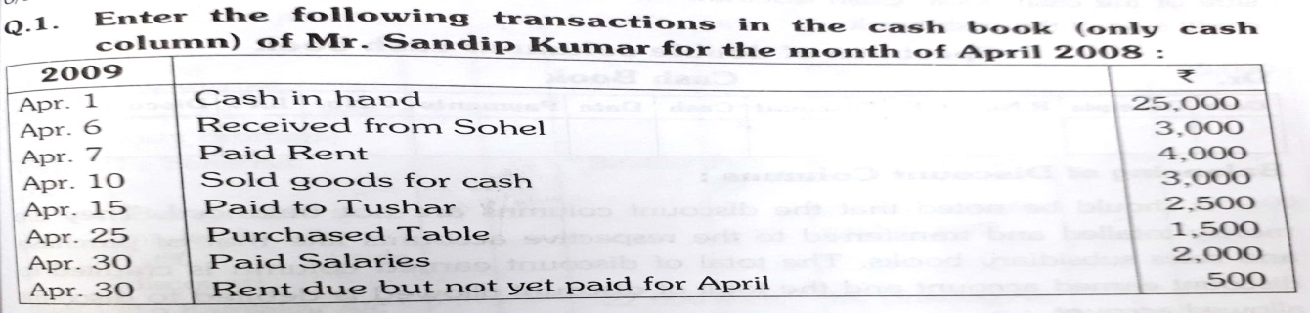

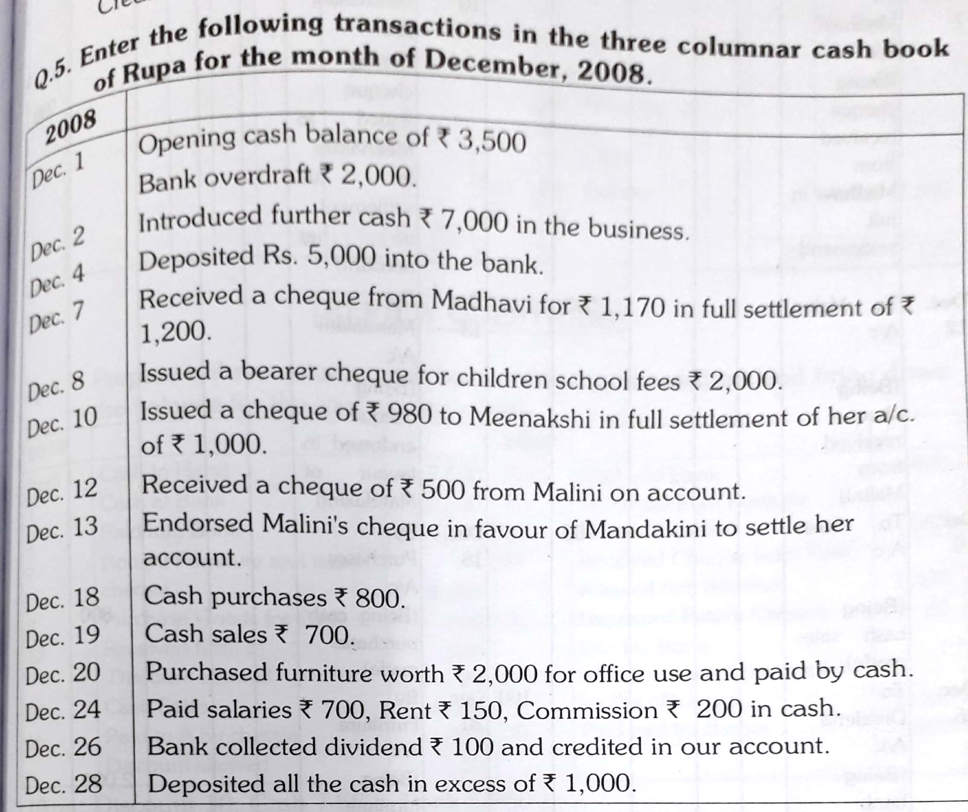

LEDGER
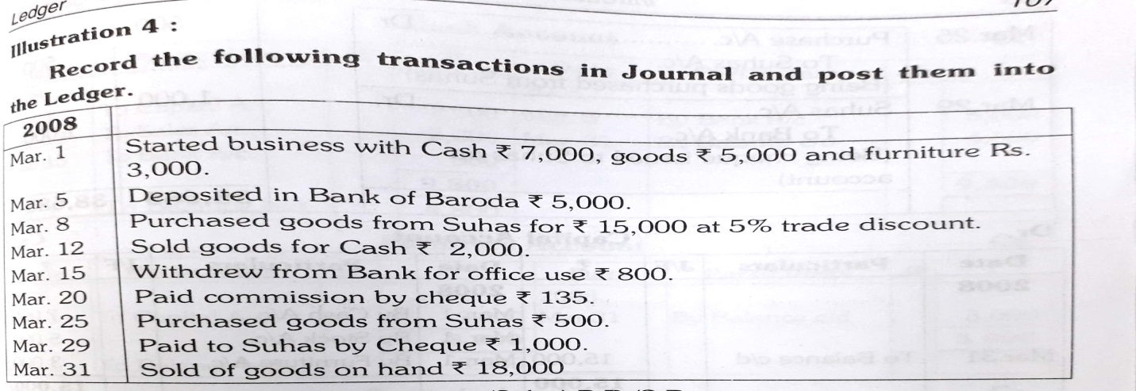

TRIAL BALANCE
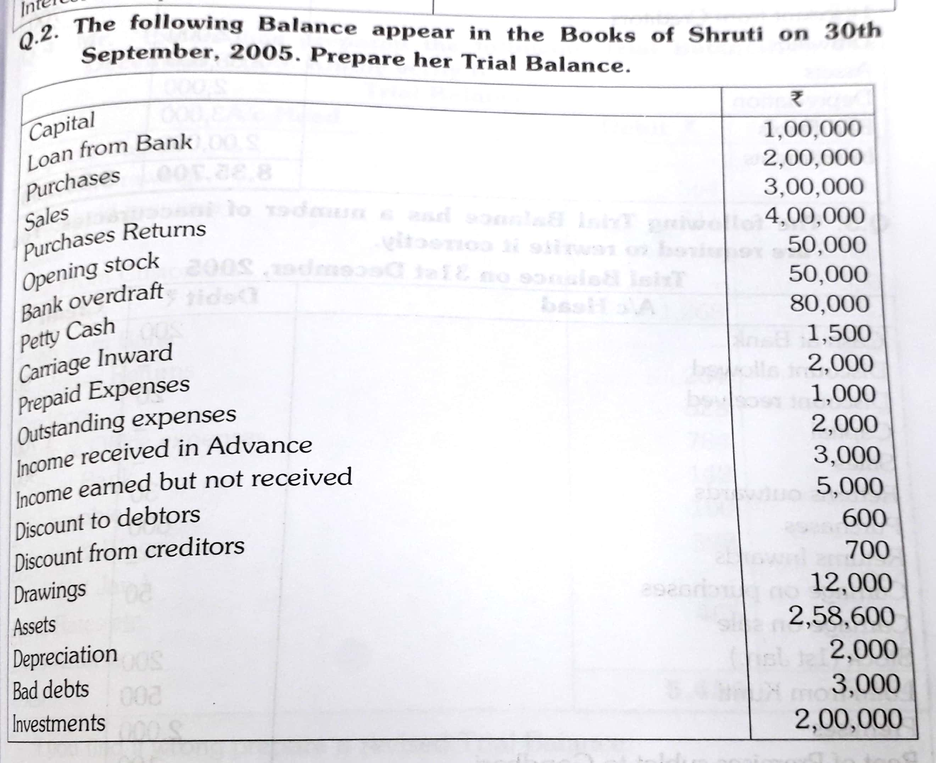

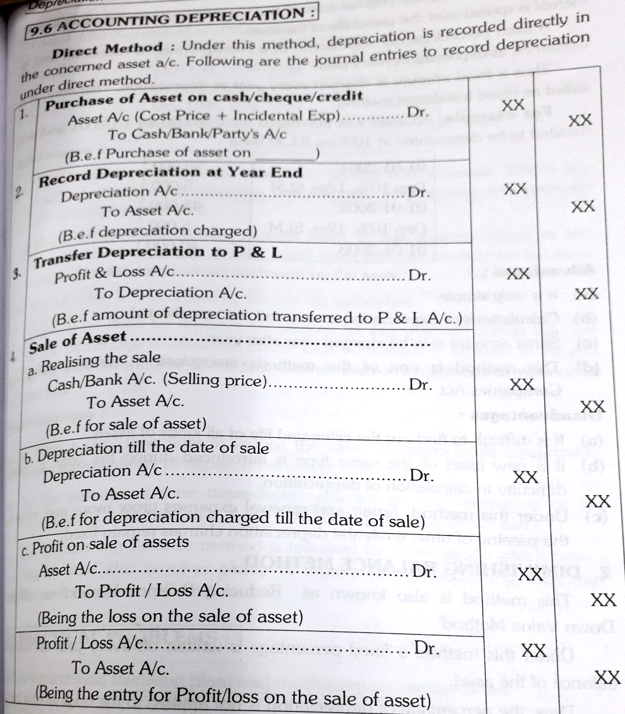

DEPRECIATION – WDV METHOD
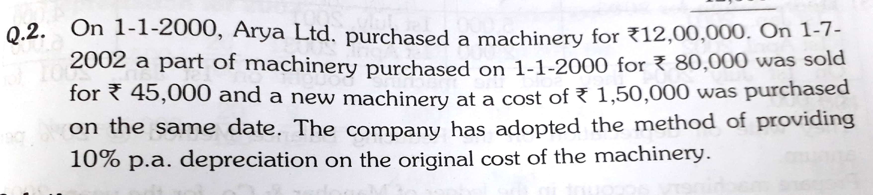

DEPRECIATION – REDUCING BALANCE METHOD
